

Mohammad Ali Jinnah University

Chartered by Government of Sindh - Recognized by HEC

**Assignment 1**

**Name:** Muhamad Fahad

**Id:** FA19-BSSE-0014

**Subject:** [Software Engineering Lab FA20](https://classroom.google.com/c/MTQ5NjQ3NDE4MTA2)

**Section:** CM

**Teacher:** ABDUL BASIT

**Date:** Thursday, November 26, 2020

**Assignment # 1**

**Question # 1.**

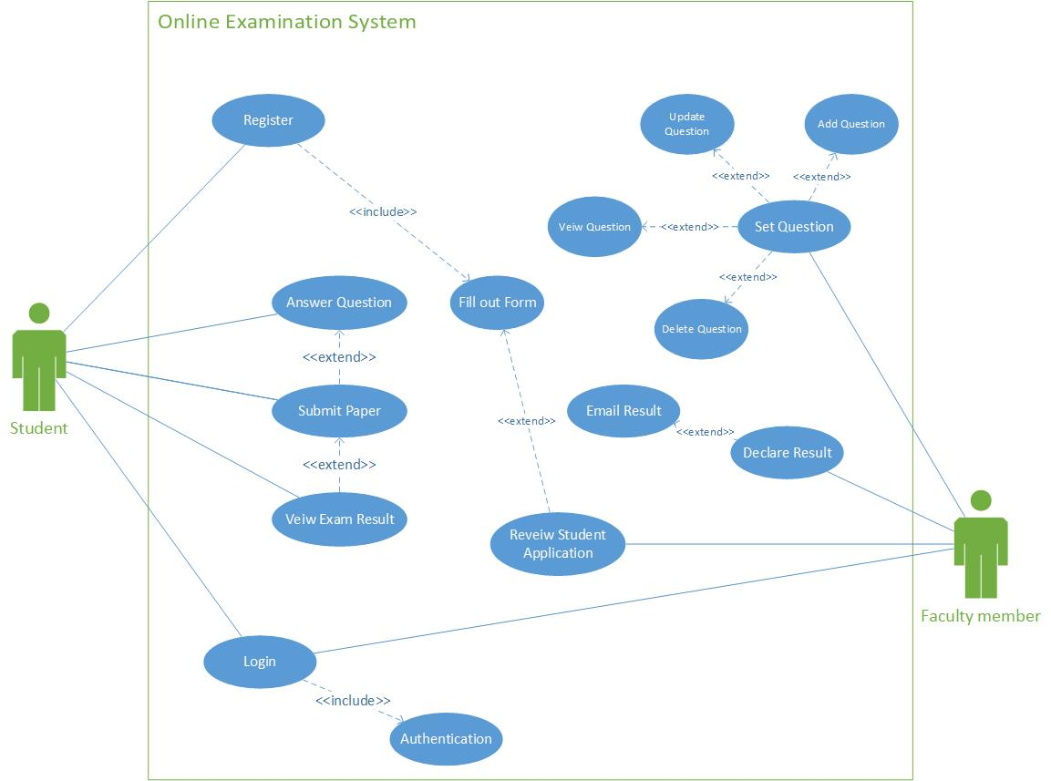

**Question#2**

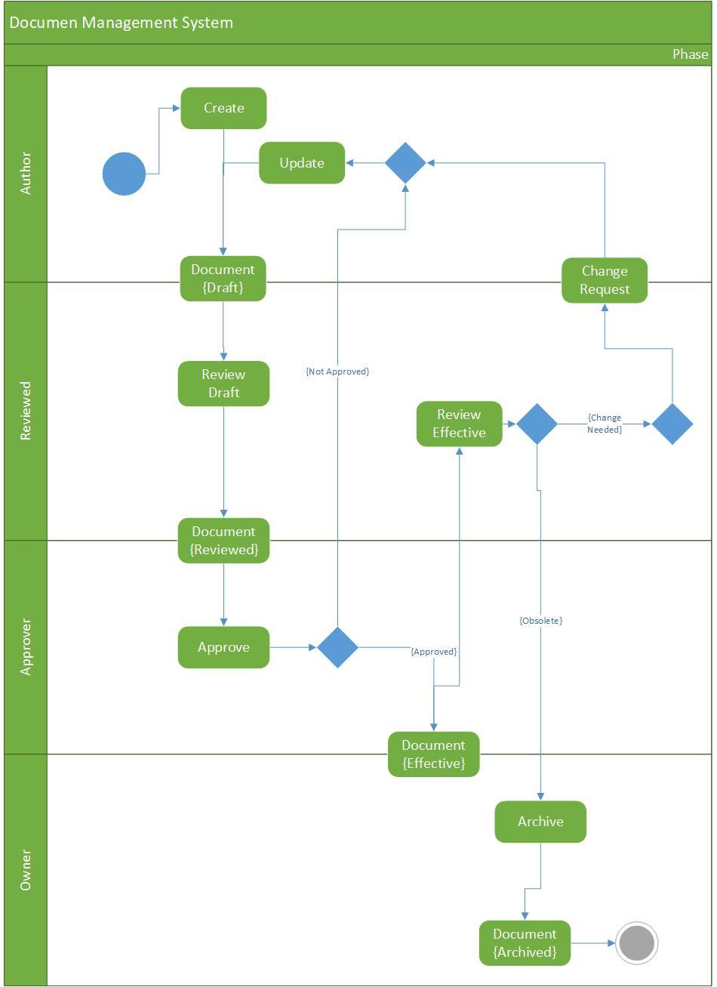

**Question# 3**

